भारतमौसमविज्ञानविभाग |  | India Meteorological Department
Wednesday,11th June 2025 (21 Jyeshtha 1947 Saka)
Summary of observations recorded at 0830 hours IST: The Northern Limit of Monsoon continues to pass through 17.0°N/55°E, 17.5°N/60°E, 18°N/65°E, 18.5°N/70°E, Mumbai, Ahilyanagar, Adilabad, Bhawanipatna, Puri, Sandhead Island, 23.5°N/89.5°E, Balurghat, 30°N/85°E. Conditions are likely to be favourable for further advancement of Southwest monsoon over some more parts of central and adjoining east India around 14th June. An upper air cyclonic circulation lay over westcentral Bay of Bengal off north coastal Andhra Pradesh coast and extended upto 5.8 km above m. s. l. A trough ran from northeast Rajasthan to the upper air cyclonic circulation over westcentral Bay of Bengal across Madhya Pradesh, Chhattisgarh at 0.9 km above m. s. l. The upper air cyclonic circulation over central parts of south Uttar Pradesh lay over southeast Uttar Pradesh & neighbourhood today morning. It lay over over east Uttar Pradesh and extended upto 1.5 km above m. s. l. An upper air cyclonic circulation ay over north Haryana & Chandigarh at 0.9 km above m. s. l. A fresh Western Disturbance as a trough in middle tropospheric westerlies with its axis at 5.8 km above m. s. l. ran roughly along Long. 58°E to the north of Lat. 30°N and it is likely to affect northwest India from 13th June 2025. The upper air cyclonic circulation over north Pakistan & neighborhood off Punjab became less marked. The upper air cyclonic circulation over north Chhattisgarh lay over east Madhya Pradesh and neighbourhood at 0.9 km above m. s. l. today morning. It became less marked.. The upper air cyclonic circulation over north Odisha & neighbourhood became less marked. The trough from north Tamil Nadu to south Maharashtra coast across Interior Karnataka lay as a shear zone roughly along Lat. 15°N over the Indian Region became less marked. The Western Disturbance as a trough in middle tropospheric westerlies with its axis at 5.8 km above m. s. l. roughly along Long. 64°E to the north of Lat. 28°N became less marked. The trough from the cyclonic circulation over northwest Uttar Pradesh and neighbourhood to Telangana ran from northwest Uttar Pradesh to west central Bay of Bengal across east Madhya Pradesh, south Chhattisgarh and south Odisha at 0.9 km above m. s. l. today morning. It became less marked.
Day temperatures were markedly above normal (> 5.1°C) at many places over Assam & Meghalaya and Jammu-Kashmir-Ladakh-Gilgit-Baltistan-Muzaffarabad; at most places over Arunachal Pradesh and Punjab; at few places over sub Himalayan West Bengal & Sikkim, Haryana-Chandigarh-Delhi, Himachal Pradesh and east Madhya Pradesh; at isolated places over west Uttar Pradesh, west Rajasthan, east Rajasthan, west Madhya Pradesh, Vidarbha and Tamil Nadu, Puducherry & Karaikal. appreciably above normal (3.1°C to 5.0°C) at many places over Bihar and Uttarakhand; at few places over Nagaland, Manipur, Mizoram & Tripura and The upper air cyclonic circulation over north Haryana & neighborhood became less marked east Uttar Pradesh; at isolated places over Gangetic West Bengal, Odisha and Kerala & Mahe. above normal (1.6°C to 3.0°C) at many places over coastal Karnataka; at few places over Lakshadweep; at isolated places over Jharkhand, Saurashtra & Kutch, Konkan & Goa, Madhya Maharashtra, Marathwada, coastal Andhra Pradesh & Yanam, Telangana and north interior Karnataka; near normal (-1.5°C to 1.5°C) at many places over Andaman & Nicobar Islands and Rayalaseema; at most places over Gujarat region, Chhattisgarh and south interior Karnataka. The highest maximum temperature of 47.6°C was reported at Bhatinda (Punjab).
The Southwest Monsoon has been active over Kerala. It has been subdued over Arunachal Pradesh, Assam & Meghalaya and Konkan & Goa.
Total 266 Station reported rainfall today. Total rainfall is 82.5 cm. Total 256 Station reported rainfall today whose normals are available. Total rainfall is 76.7 cm with normal station total is 157.7 cm.
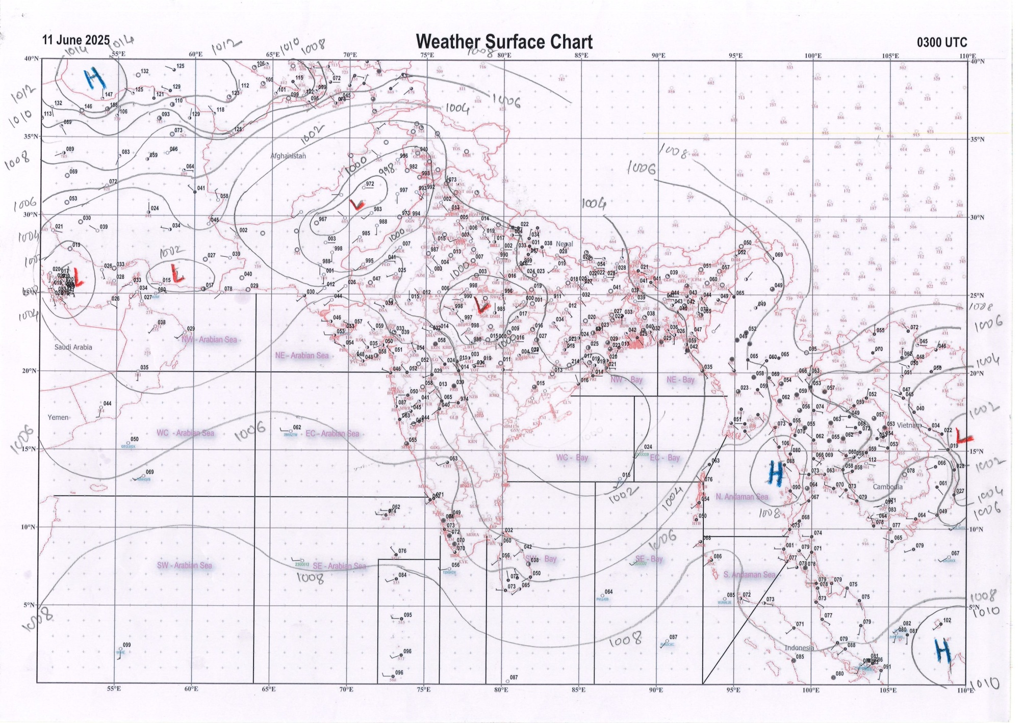 | 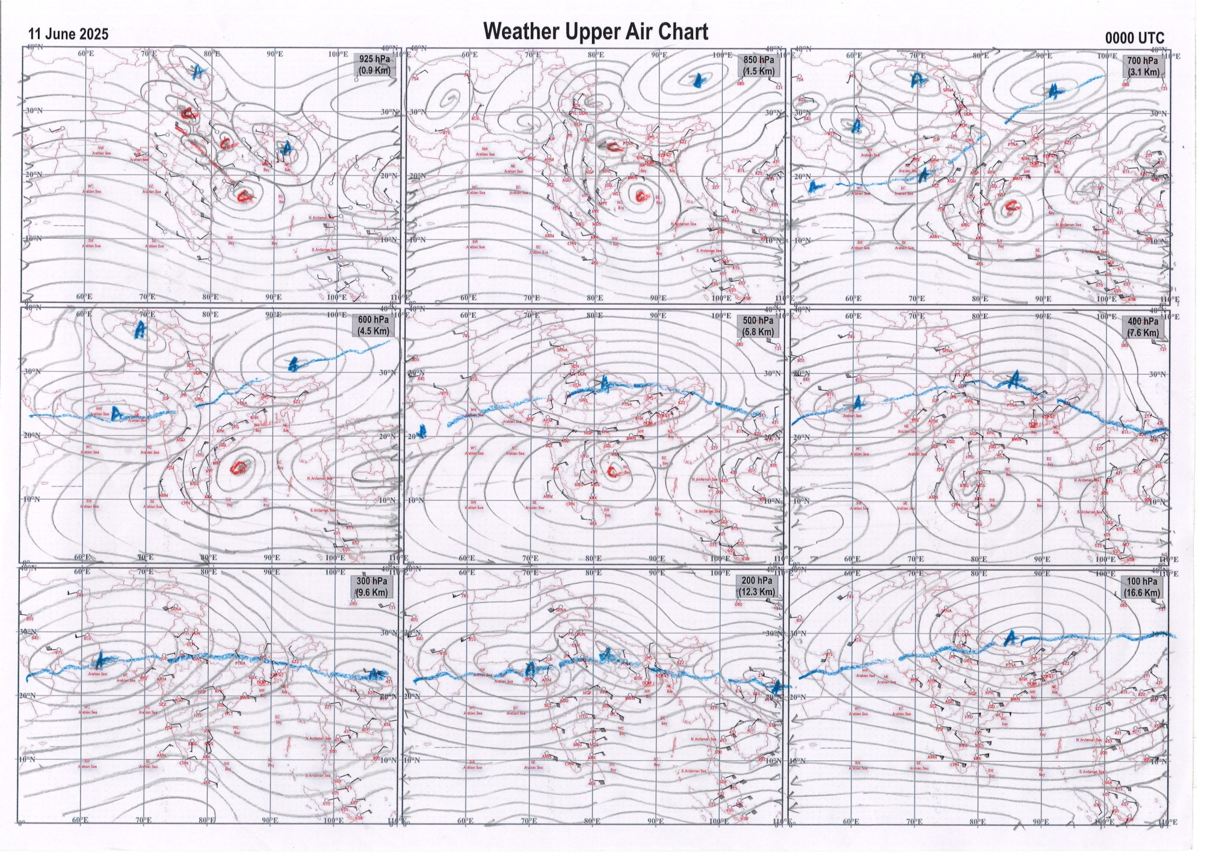
g.1. Analysed surface chart based on 03z observation | Fig.2. Analysed upper air chart based on 00z observation

Dr. S.D.Sanap
Scientist ‘D’
CR & S Office, Pune  Issued at 1245 hrs. IST |  | Weather Forecasting Division  CR&S, Pune

Indian regions | Realised rainfall (chief amount in cm during past 24 hrs):
East | many places: Nagaland-Manipur-Mizoram-Tripura+  isolated places: Arunachal Pradesh, Assam & Meghalaya, West Bengal & Sikkim, Odisha+ and Jharkhand  dry weather: Bihar  Sonamura 8.9, Sonamura ARG 8.1, Ganjam 6.6, Th rampur 6.0, Jung ARG 2.5, Tadong 2.0, Chouldhuwaghat ARG & Chauldhowaghat 1.9 each, Majhgaon 1.8, Gangtok 1.7, Agartala AP 1.5, Silchar 1.4, Rongli & Koraput 1.2 each, Miao & Uluberia 0.8 each, Sagar island PTO 0.7, Alipore 0.6, Chakradharpur 0.1.
North | isolated places: Uttarakhand+  dry weather: Uttar Pradesh, Haryana, Punjab, Himachal Pradesh, Jammu-Kashmir and Ladakh and Rajasthan  Sama 9.0, Ukhimath 7.1, Dharchula 4.3.
Central | a few places: Vidarbha and Chhattisgarh+  isolated places: Madhya Pradesh  Kutaru 7.5, Raipur city 6.4, Raipur 4.9, Thikri 4.0, Chamorshi 3.3, Korpana 3.2, Balaghat-aws 2.3, Amarkantak 2.1, Gondia 1.5, Pithampur 1.1, Mandla 0.7, Gogawan 0.6.
Peninsula | most places: Kerala+++  many places: Telangana+++  a few places: coastal Andhra Pradesh+, Tamil Nadu+, coastal Karnataka+ and south interior Karnataka  isolated places: Konkan & Goa◆, Madhya Maharashtra, Marathwada, Rayalaseema and north interior Karnataka  dry weather: Gujarat State  Sengulam dam AWS 13.6, Sathupalle 13.1, Munnar kseb 12.9, Konijerla 11.8, Gudivada 10.7, Avadi 9.0, Chinnakalar 7.9, Kaikalur 7.5, Valparai PTO 7.2, Mangaluru AP 7.0, Masulipatnam cdr 6.8, Kottayam 6.2, Kota 5.0, Almel ARG 4.7, Mulki 4.6, Lepakshi 3.8, Chilamathur & Bengaluru city 3.3 each, Davanagere 3.1, Bhalki 2.8, Himayatnagar 2.5, Parbhani , Kinwat & Begur 2.3 each, Cuddapah 1.5, Nizamabad 1.4, Bidar PTO 0.9, Pandharpur 0.7, Mohol 0.4, Canacona 0.2, Sanguem & Devgad 0.1 each.
Islands | most places: Andaman & Nicobar  many places: Lakshadweep  Amini 1.1, Car Nicobar 1.0, Long island 0.9, Port blair 0.7, Minicoy 0.3.
Table 2. Forecast / warnings (distribution of rain / thundershowers) for 7 days (valid from time of origin upto 0830 hrs IST of next day)
Sr. No |  | Sub-division Name | Day 1 | Day 2 | Day 3 | Day 4 | Day 5 | Day 6 | Day 7 | Sr. No. | Sub-division Name | Day 1 | Day 2 | Day 3 | Day 4 | Day 5 | Day 6 | Day 7
 |  |  | 11 Jun | 12 Jun | 13 Jun | 14 Jun | 15 Jun | 16 Jun | 17 Jun |  |  | 11 Jun | 12 Jun | 13 Jun | 14 Jun | 15 Jun | 16 Jun | 17 Jun
 | 1 | Andaman Nicobar Islands | W  | W+ | F+ | F | F | F | F | 19 | west Madhya Pradesh | I  + | I+ | S+ | S | S + | F | F
 | 2 | Arunachal Pradesh | I + | S  | S+ | F +  | F +  | F+  | F +  | 20 | east Madhya Pradesh | I + | I+ | S+ | S | S + | F | F
 | 3 | Assam-Meghalaya | S + | S + | S +  | S +  | S +  | F +  | F +  | 21 | Gujarat region | I | I | I | I  | S + | S | S
 | 4 | Nagaland-Manipur-Mizoram-Tripura | F+ | S +  | S +  | F +  | F +  | F + | F +  | 22 | Saurashtra and Kutch | I | I | I | I | I | S | S
 | 5 | Sub Himalayan West Bengal/Sikkim | S  | F  | F+ | F + | F + | F | F | 23 | Konkan and Goa | S +  | F# | W# | W#+ | W++ | W ++ | W +
 | 6 | Gangetic West Bengal | S  | F  | F  | F  | F+ | F | F | 24 | Madhya Maharashtra | I +  | F++ | F++ | S+ | S + | S + | F +
 | 7 | Odisha | S +  | S +  | S + | S + | S + | S + | S + | 25 | Marathwada | S +  | F + | F + | S+ | I + | I | S
 | 8 | Jharkhand | S  | S  | S  | F  | F+ | F | F | 26 | Vidarbha | S  | S | F | F+ | F+ | F + | F +
 | 9 | Bihar | S + | F  + | S  | S  | S+ | S | S | 27 | Chhattisgarh | I +  | S  | S  | F+ | F +  | F + | F +
 | 10 | east Uttar Pradesh | I + | I | I  | S  | S+ | S  | I  | 28 | Coastal Andhra Pradesh and Yanam | W++ | F  | F  | F | F  | S | S
 | 11 | west Uttar Pradesh | I + | I + | I + | I  | I+ | S  | S  | 29 | Telangana | F++ | F+ | F+ | F+ | F + | F | F
 | 12 | Uttarakhand | S +  | F+ | F+ | F+ | F+ | F+ | F+ | 30 | Rayalaseema | W + | W  | F  | S | S  | F | S
 | 13 | Haryana,Chandigarh and Delhi | D + | D + | I+ | I + | I + | I  | S  | 31 | Tamil Nadu, Puducherry and Karaikal | S +  | S++ | S++ | S# | S# | S ++ | I ++
 | 14 | Punjab | D + | D + | D + | I + | I + | I  | I  | 32 | Coastal Karnataka | W++ | W# | W# | W # | W # | W # | W ++
 | 15 | Himachal Pradesh | D + | D + | D + | I  | S+ | S | S  | 33 | North interior Karnataka | W++ | W# | W++ | W++ | W++ | W++ | W +
 | 16 | Jammu-Kashmir and Ladakh | D + | D + | D + | I | I | I | I | 34 | South interior Karnataka | W++ | W# | F #  | F #  | W #  | W # | W ++
 | 17 | west Rajasthan | D + | D + | D + | D + | I++ | I  | I  | 35 | Kerala and Mahe | W++ | W++ | W++ | W# | W# | W # | W
 | 18 | east Rajasthan | D + | D + | I + | I | I + | I  | I  | 36 | Lakshadweep | W  | W  | W  | W+ | W +  | W | W
Legends: D = DryI = IsolatedS = ScatteredF = Fairly widespreadW = Widespread #= heavy to very heavy rain at a few places with extremely heavy rain at isolated places +++= heavy rain at a few places with very heavy rain at Isolated places ++= heavy to very heavy rainfall @=Isolated exceptionally heavy rainfall + = heavy rain ●/*= rain or snow ♦ = very light rain ≡=fog= thunderstorm with lightning =Squall / Gusty / gale / strong wind ­ =cold wave/cold day += heat wave/warm night/hot and humid weathe r=Duststorm =ground frost = Hail

Fig. 4: Districtwise warnings for five days for Maharashtra State
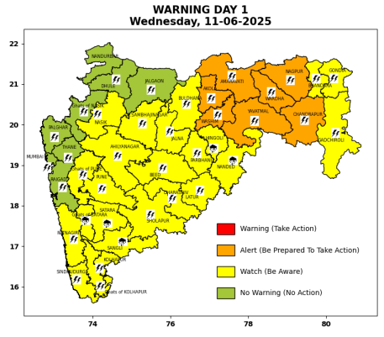 | 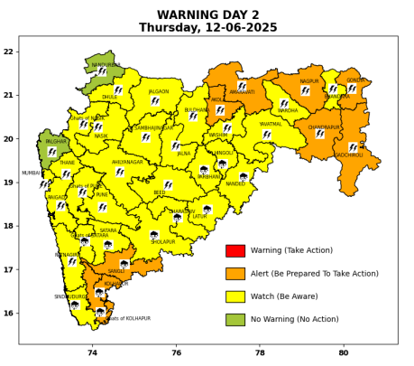 | 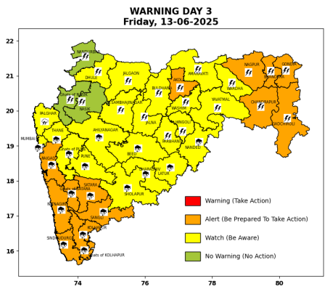 | 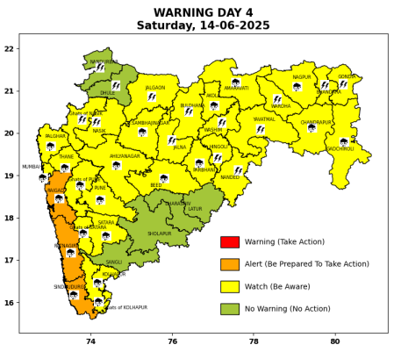 | 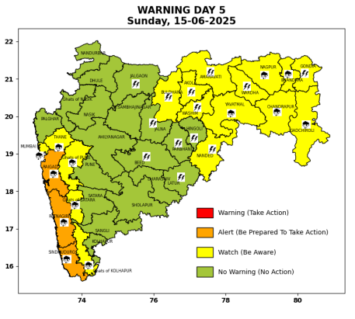

Pune, Lohegaon and Pashan observations at 0830 hrs. IST of Today
 | Temperature (°C) |  |  |  |  | Humidity (%) |  |  |  | Rainfall (mm)
 | Max.  past  24 hrs | Dep.  from  normal | Min.  past  24 hrs. | Dep.  from  normal | Dry  Bulb | At 0830 hrs. IST | Dep.  From  normal | At 1730  hrs. IST of y’day | Dep.  from  normal | Past  24 hrs. | Since  1st June | Dep.  from  normal
PNE | 31.5 | -0.9 | 23.9 | 0.6 | 26.6 | 73 | -4 | 67 | 1 | 0.0 | 38.1 | -18.5
PSN | 30.6 | - | 22.9 | - | 26.2 | 81 | - | 73 | - | 0.0 | 26.3 | -
LHG | 33.3 | 0.3 | 25.9 | 4.9 | 27.7 | 62 | -12 | 58 | -1 | 0.0+ | 54.8 | 12.2

 |  |  |  |  |  |  | Local (Pune and neighbourhood) forecast
Max./Min. Temperature (°C) |  |  |  |  |  |  |  |  | Weather
Date | Pune | Pashan | Lohegaon | Chinchwad | Lavale | Magarpatta | NDA | Koregoan Park
11/06/25 | 31/23.9* | 29/22.9* | 32/25.9* | 31/24.7* | 31/-- | 32/25.8* | 30/24.0* | 31/25.7* | Partly cloudy sky becoming generally cloudy sky towards afternoon/evening. Very light to light rain very likely.
12/06/25 | 30/24 | 30/23 | 32/26 | 30/25 | 29/23 | 31/26 | 29/24 | 31/25 | Partly cloudy sky becoming generally cloudy sky towards afternoon/evening. Light rain very likely.
13/06/25 | 29/23 | 29/22 | 31/25 | 29/24 | 28/22 | 30/25 | 28/23 | 30/24 | Partly cloudy sky becoming generally cloudy sky towards afternoon/evening. Light to moderate rain very likely.
14/06/25 | 30/23 | 30/22 | 32/25 | 30/24 | 29/22 | 31/25 | 29/23 | 31/24 | Partly cloudy sky becoming generally cloudy sky towards afternoon/evening. Light rain likely.
15/06/25 | 30/24 | 30/23 | 32/26 | 30/25 | 29/23 | 31/26 | 29/24 | 31/25 | Partly cloudy sky becoming generally cloudy sky towards afternoon/evening. Light rain likely.
16/06/25 | 29/23 | 29/22 | 31/25 | 29/24 | 28/22 | 30/25 | 28/23 | 30/24 | Partly cloudy sky becoming generally cloudy sky towards afternoon/evening. Light to moderate rain likely.
17/06/25 | 29/23 | 29/22 | 31/25 | 29/24 | 28/22 | 30/25 | 28/23 | 30/24 | Partly cloudy sky becoming generally cloudy sky towards afternoon/evening. Light to moderate rain likely.
Rainfall Distribution |  |  | Rainfall Categories | Rainfall (mm) |  | Cloud condition |  |  |  | Rainfall Intensity |  | Range
Widespread (W) | 76-100% |  | Very Light rain | Trace to 2.4 mm |  | Mainly clear sky |  | 1-2 oktas |  | Light Spell |  | 1 cm/hr
 |  |  | Light rain | 2.5 to 15.5 mm |  | Partly cloudy sky |  | 3-4 oktas |  | Moderate Spell |  | 1-2 cm/hr
Fairly Widespread (FW) | 51 – 75% |  | Moderate rain | 15.6 to 64.4 mm |  | Generally cloudy sky |  | 5-7 oktas |  | Intense Spell |  | 2-3 cm/hr
Scattered (S) | 26 – 50% |  | Heavy rain | 64.5 to 115.5 mm |  | Overcast |  | 8 oktas |  | Very Intense Spell |  | 3-5 cm/hr
isolated (I) | 1 – 25% |  | Very heavy rain | 115.6 to 204.4 mm |  |  |  |  |  | Extremely Intense Spell |  | 5-10 cm/hr
D (D) | No Rain |  | Extremely heavy rain | ≥ 204.5 mm |  |  |  |  |  | Cloudburst |  | > 10 cm/hr
Probability Terms in %: |  |  | Heavy snow | 6.5 to 11.5 cms water equivalent of rain
unlikely | < 25 |  | Very heavy snow | 11.6 to 20.4 cms water equivalent of rain
likely | between 25 50
very likely | between 51 75
most likely | >75
* = realized temperature
Mumbai (Colaba) |  |  |  | Nagpur (AP)
Date 2025 | T max °C | T min °C | Weather | T max °C | T min °C | Weather
11/06 | 33 | 27 | Partly cloudy sky with one or two spells of rain or thundershowers. | 43 | 25 | Rain or thundershowers accompanied with lightning & gusty winds(40-50kmph).
12/06 | 32 | 27 | Partly cloudy sky with possibility of moderate rain or thundershowers accompanied with lightning & gusty winds(40-50kmph). | 43 | 25 | Rain or thundershowers accompanied with lightning & gusty winds(50-60kmph).
13/06 | 32 | 27 | Generally cloudy sky with Heavy rain. | 42 | 25 | Rain or thundershowers accompanied with lightning & gusty winds(50-60kmph).
14/06 | 32 | 26 | Generally cloudy sky with Heavy rain. | 41 | 25 | Rain or thundershowers accompanied with lightning & gusty winds(40-50kmph).
15/06 | 32 | 26 | Generally cloudy sky with Heavy rain. | 41 | 24 | Rain or thundershowers accompanied with lightning & gusty winds(40-50kmph).
16/06 | 31 | 26 | Rain. | 40 | 24 | Generally cloudy sky with possibility of rain or Thunderstorm.
17/06 | 31 | 26 | Rain. | 40 | 24 | Generally cloudy sky with possibility of rain or Thunderstorm.

